Hands On - 1
HTTP Request Response
Codes:
Pom.xml:
<project xmlns="http://maven.apache.org/POM/4.0.0"
xmlns:xsi="http://www.w3.org/2001/XMLSchema-instance"
xsi:schemaLocation="http://maven.apache.org/POM/4.0.0
<modelVersion>4.0.0</modelVersion>
<groupId>com.cognizant.springlearn</groupId>
<artifactId>spring-rest-handson</artifactId>
<version>1.0</version>
<packaging>jar</packaging>
<name>Spring REST Hands-On</name>
<description>Spring Boot REST Web Service</description>
<parent>
<groupId>org.springframework.boot</groupId>
<artifactId>spring-boot-starter-parent</artifactId>
<version>3.2.0</version>
</parent>
<properties>
<java.version>17</java.version>
</properties>
<dependencies>
<!-- Spring Boot Web -->
<dependency>
<groupId>org.springframework.boot</groupId>
<artifactId>spring-boot-starter-web</artifactId>
</dependency>
<!-- Spring Boot Test -->
<dependency>
<groupId>org.springframework.boot</groupId>
<artifactId>spring-boot-starter-test</artifactId>
<scope>test</scope>
</dependency>
<!-- Lombok (Optional) -->
<dependency>
<groupId>org.projectlombok</groupId>
<artifactId>lombok</artifactId>
<optional>true</optional>
</dependency>
</dependencies>
<build>
<plugins>
<!-- Spring Boot Maven Plugin -->
<plugin>
<groupId>org.springframework.boot</groupId>
<artifactId>spring-boot-maven-plugin</artifactId>
</plugin>
</plugins>
</build>
</project>
Country.java:
package com.cognizant.springlearn;
public class Country {
private String code;
private String name;
public Country() {}
public Country(String code, String name) {
this.code = code;
this.name = name;
}
public String getCode() {
return code;
}
public void setCode(String code) {
this.code = code;
}
public String getName() {
return name;
}
public void setName(String name) {
this.name = name;
}
}
HelloController.java:
package com.cognizant.springlearn.controller;
import org.springframework.web.bind.annotation.GetMapping;
import org.springframework.web.bind.annotation.RestController;
public class HelloController {
@GetMapping("/hello")
public String sayHello() {
return "Hello World!!";
}
}

CountryService.java:
package com.cognizant.springlearn.service;
import com.cognizant.springlearn.Country;
import com.cognizant.springlearn.service.exception.CountryNotFoundException;
import org.springframework.stereotype.Service;
import java.util.ArrayList;
import java.util.List;
public class CountryService {
private static final List<Country> countries = new ArrayList<>();
static {
countries.add(new Country("IN", "India"));
countries.add(new Country("US", "United States"));
countries.add(new Country("JP", "Japan"));
countries.add(new Country("DE", "Germany"));
}
public Country getCountry(String code) throws CountryNotFoundException {
return countries.stream()
.filter(c -> c.getCode().equalsIgnoreCase(code))
.findFirst()
.orElseThrow(() -> new CountryNotFoundException("Country not found"));
}
public List<Country> getAllCountries() {
return countries;
}
}
CountryNotFoundException.java:
package com.cognizant.springlearn.service.exception;
import org.springframework.http.HttpStatus;
import org.springframework.web.bind.annotation.ResponseStatus;
@ResponseStatus(value = HttpStatus.NOT_FOUND, reason = "Country not found")
public class CountryNotFoundException extends Exception {
public CountryNotFoundException(String message) {
super(message);
}
}
CountryController.java:
package com.cognizant.springlearn.controller;
import com.cognizant.springlearn.Country;
import com.cognizant.springlearn.service.CountryService;
import com.cognizant.springlearn.service.exception.CountryNotFoundException;
import org.springframework.beans.factory.annotation.Autowired;
import org.springframework.web.bind.annotation.*;
import java.util.List;
@RestController
public class CountryController {
@Autowired
private CountryService countryService;
@RequestMapping("/country")
public Country getCountryIndia() throws CountryNotFoundException {
return countryService.getCountry("IN");
}
@GetMapping("/countries")
public List<Country> getAllCountries() {
return countryService.getAllCountries();
}
@GetMapping("/countries/{code}")
public Country getCountry(@PathVariable String code) throws CountryNotFoundException {
return countryService.getCountry(code);
}
}
SpringLearnApplication.java:
package com.cognizant.springlearn;
import org.springframework.boot.SpringApplication;
import org.springframework.boot.autoconfigure.SpringBootApplication;
@SpringBootApplication
public class SpringLearnApplication {
public static void main(String[] args) {
SpringApplication.run(SpringLearnApplication.class, args);
}
}
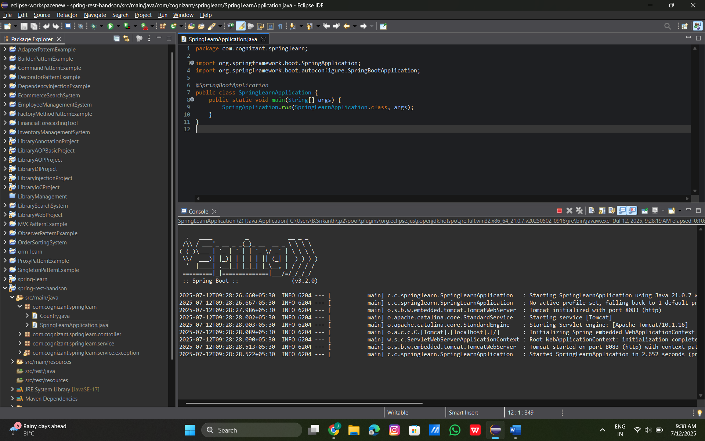

Hands On - 2
Hello World RESTful Web Service
Codes:
Country.xml:
<?xml version="1.0" encoding="UTF-8"?>
<beans xmlns="http://www.springframework.org/schema/beans"
xmlns:xsi="http://www.w3.org/2001/XMLSchema-instance"
xsi:schemaLocation="
http://www.springframework.org/schema/beans
https://www.springframework.org/schema/beans/spring-beans.xsd">
<bean id="in" class="com.cognizant.springlearn.Country">
<property name="code" value="IN"/>
<property name="name" value="India"/>
</bean>
</beans>
Country . java:
package com.cognizant.springlearn;
public class Country {
private String code;
private String name;
public Country() {} // Required for XML
public Country(String code, String name) {
this.code = code;
this.name = name;
}
public String getCode() {
return code;
}
public void setCode(String code) {
this.code = code;
}
public String getName() {
return name;
}
public void setName(String name) {
this.name = name;
}
}

CountryController.java:
package com.cognizant.springlearn.controller;
import com.cognizant.springlearn.Country;
import org.springframework.beans.factory.xml.XmlBeanFactory;
import org.springframework.core.io.ClassPathResource;
import org.springframework.web.bind.annotation.RequestMapping;
import org.springframework.web.bind.annotation.RestController;
import org.springframework.web.bind.annotation.GetMapping;
@RestController
public class CountryController {
@RequestMapping("/country")
public Country getCountryIndia() {
XmlBeanFactory factory = new XmlBeanFactory(new ClassPathResource("country.xml"));
Country in = (Country) factory.getBean("in");
return in;
}
}
SpringLearnApplication.java:
package com.cognizant.springlearn;
import org.springframework.boot.SpringApplication;
import org.springframework.boot.autoconfigure.SpringBootApplication;
@SpringBootApplication
public class SpringLearnApplication {
public static void main(String[] args) {
SpringApplication.run(SpringLearnApplication.class, args);
}
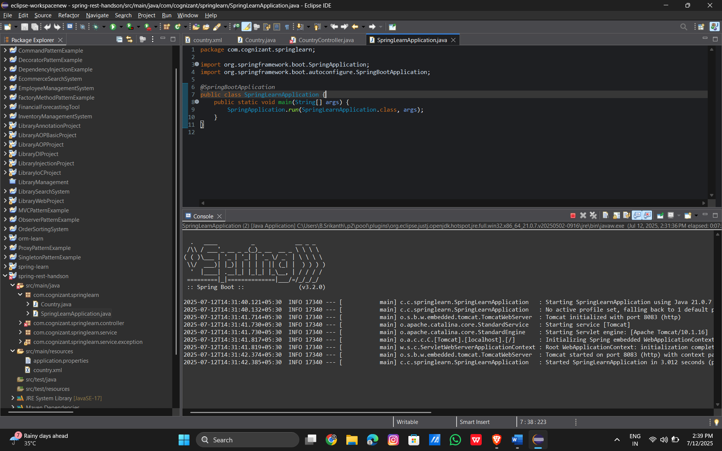
}
HandsOn – 3
REST - Country Web Service
Codes:
country.xml:
<?xml version="1.0" encoding="UTF-8"?>
<beans xmlns="http://www.springframework.org/schema/beans"
xmlns:xsi="http://www.w3.org/2001/XMLSchema-instance"
xsi:schemaLocation="
http://www.springframework.org/schema/beans
https://www.springframework.org/schema/beans/spring-beans.xsd">
<bean id="countryList" class="java.util.ArrayList">
<constructor-arg>
<list>
<bean class="com.cognizant.springlearn.Country">
<property name="code" value="IN"/>
<property name="name" value="India"/>
</bean>
<bean class="com.cognizant.springlearn.Country">
<property name="code" value="US"/>
<property name="name" value="United States"/>
</bean>
<bean class="com.cognizant.springlearn.Country">
<property name="code" value="JP"/>
<property name="name" value="Japan"/>
</bean>
<bean class="com.cognizant.springlearn.Country">
<property name="code" value="DE"/>
<property name="name" value="Germany"/>
</bean>
</list>
</constructor-arg>
</bean>
</beans>
CountryController.java:
package com.cognizant.springlearn.controller;
import com.cognizant.springlearn.Country;
import org.springframework.beans.factory.xml.XmlBeanFactory;
import org.springframework.core.io.ClassPathResource;
import org.springframework.web.bind.annotation.RequestMapping;
import org.springframework.web.bind.annotation.RestController;
import org.springframework.web.bind.annotation.GetMapping;
import java.util.List;
@RestController
public class CountryController {
// Hands-On 2: Returns the India country bean
@RequestMapping("/country")
public Country getCountryIndia() {
XmlBeanFactory factory = new XmlBeanFactory(new ClassPathResource("country.xml"));
Country in = (Country) factory.getBean("in");
return in;
}
// Hands-On 3: Returns all countries from XML
@GetMapping("/countries")
public List<Country> getAllCountries() {
XmlBeanFactory factory = new XmlBeanFactory(new ClassPathResource("country.xml"));
List<Country> countryList = (List<Country>) factory.getBean("countryList");
return countryList;
}
}
SpringLearnApplication.java:
package com.cognizant.springlearn;
import org.springframework.boot.SpringApplication;
import org.springframework.boot.autoconfigure.SpringBootApplication;
@SpringBootApplication
public class SpringLearnApplication {
public static void main(String[] args) {
SpringApplication.run(SpringLearnApplication.class, args);
}
}
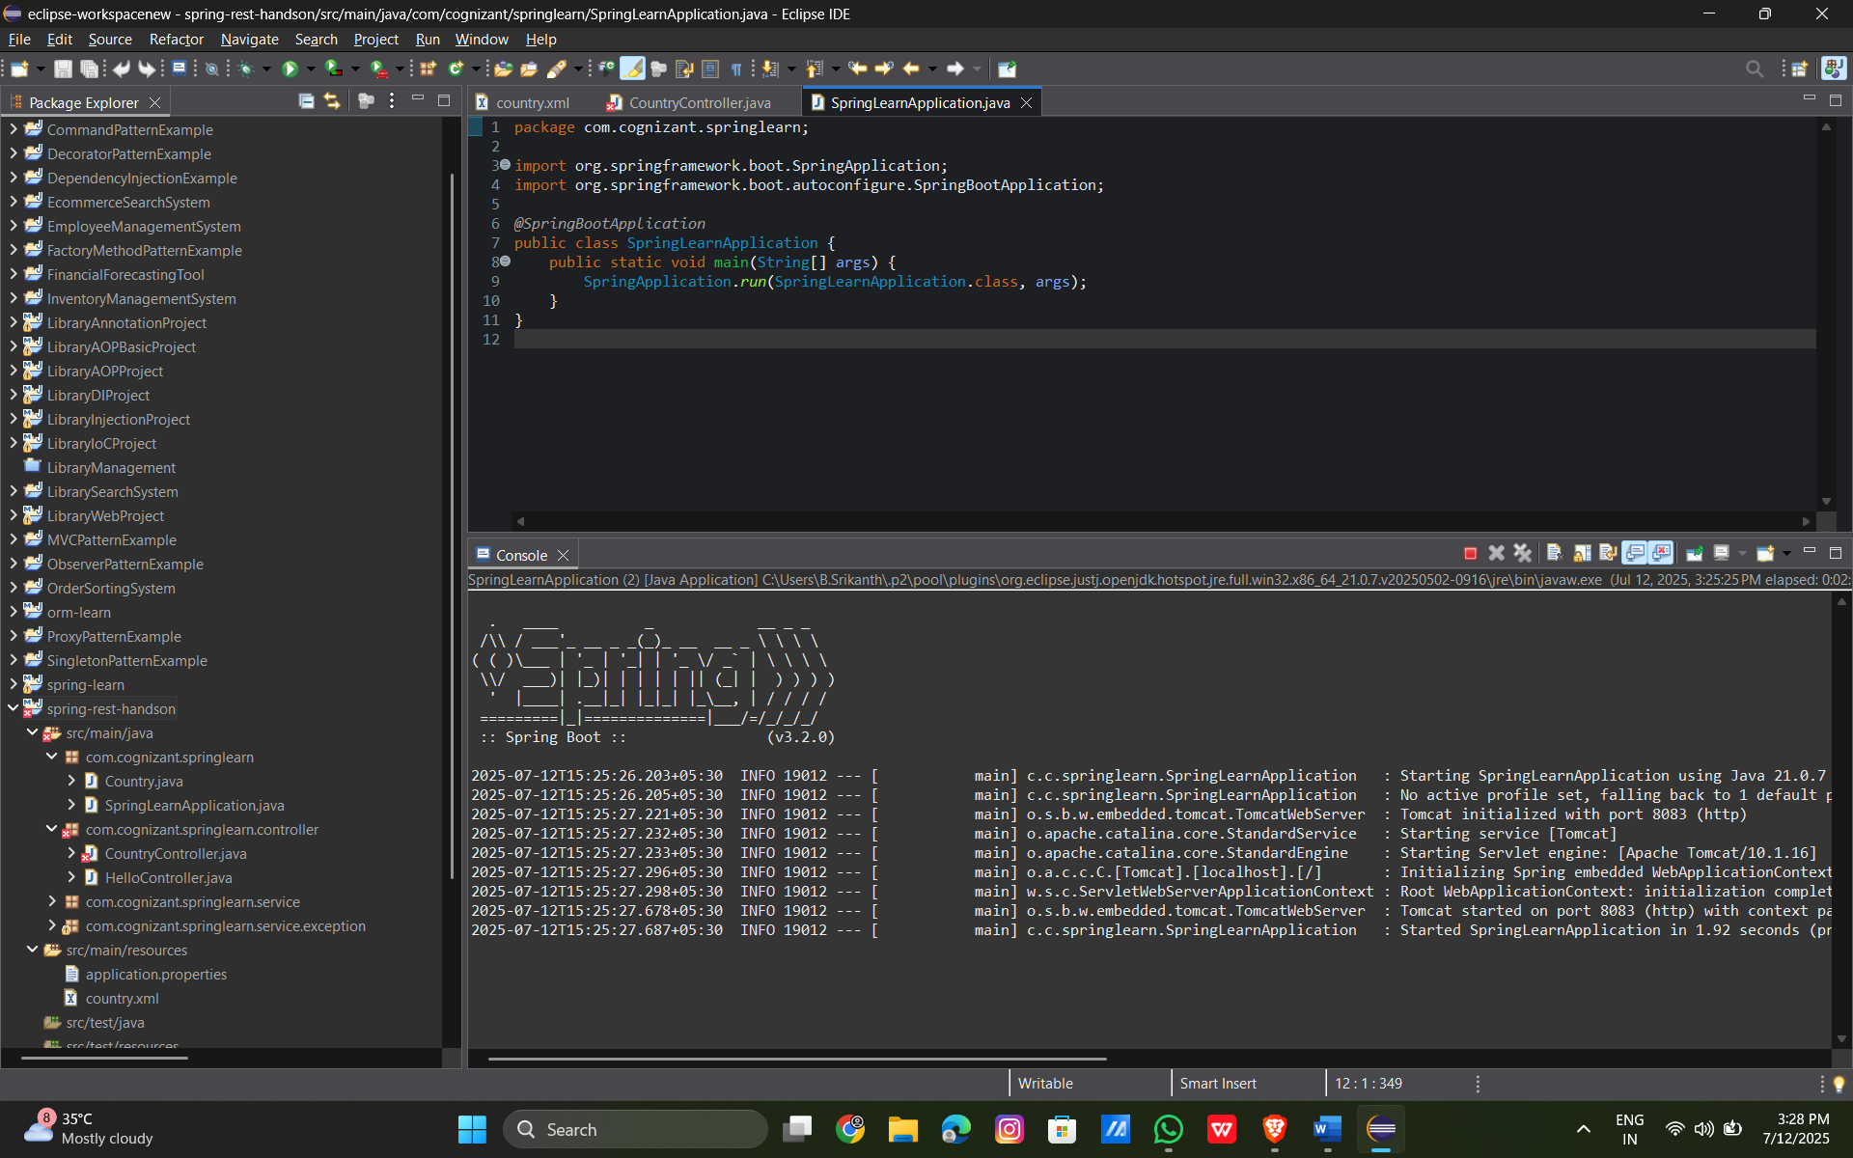

Hands On – 4
REST - Get all countries
Codes:
CountryController.java:
package com.cognizant.springlearn.controller;
import com.cognizant.springlearn.Country;
import org.springframework.beans.factory.xml.XmlBeanFactory;
import org.springframework.core.io.ClassPathResource;
import org.springframework.web.bind.annotation.*;
import java.util.List;
@RestController
public class CountryController {
// Hands-On 2: Returns the India country bean
@RequestMapping("/country")
public Country getCountryIndia() {
XmlBeanFactory factory = new XmlBeanFactory(new ClassPathResource("country.xml"));
Country in = (Country) factory.getBean("in");
return in;
}
@GetMapping("/countries")
public List<Country> getAllCountries() {
XmlBeanFactory factory = new XmlBeanFactory(new ClassPathResource("country.xml"));
List<Country> countryList = (List<Country>) factory.getBean("countryList");
return countryList;
}
@GetMapping("/countries/{code}")
public Country getCountryByCode(@PathVariable String code) {
XmlBeanFactory factory = new XmlBeanFactory(new ClassPathResource("country.xml"));
List<Country> countryList = (List<Country>) factory.getBean("countryList");
for (Country country : countryList) {
if (country.getCode().equalsIgnoreCase(code)) {
return country;
}
}
return null;
}
}
SpringLearnApplication.java:
package com.cognizant.springlearn;
import org.springframework.boot.SpringApplication;
import org.springframework.boot.autoconfigure.SpringBootApplication;
@SpringBootApplication
public class SpringLearnApplication {
public static void main(String[] args) {
SpringApplication.run(SpringLearnApplication.class, args);
}
}
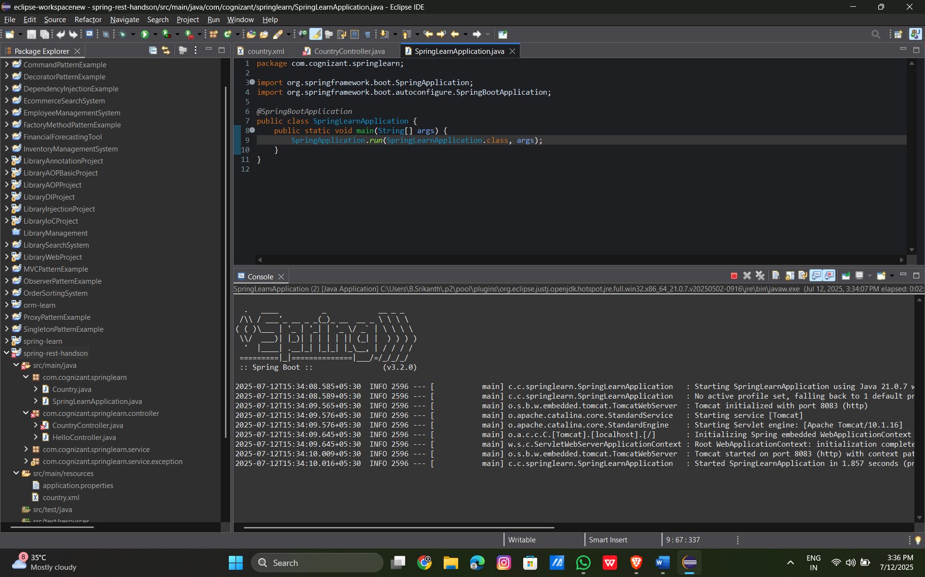

Hands On – 5
REST - Get country based on country code
Codes:
CountryNotFoundException.java:
package com.cognizant.springlearn.service.exception;
import org.springframework.http.HttpStatus;
import org.springframework.web.bind.annotation.ResponseStatus;
@ResponseStatus(value = HttpStatus.NOT_FOUND, reason = "Country not found")
public class CountryNotFoundException extends Exception {
public CountryNotFoundException(String message) {
super(message);
}
}
SpringLearnApplication.java:
package com.cognizant.springlearn;
import org.springframework.boot.SpringApplication;
import org.springframework.boot.autoconfigure.SpringBootApplication;
@SpringBootApplication
public class SpringLearnApplication {
public static void main(String[] args) {
SpringApplication.run(SpringLearnApplication.class, args);
}
}

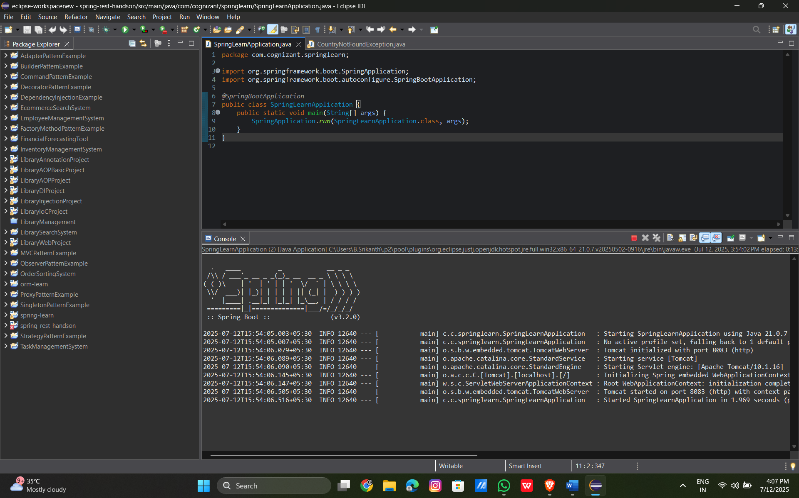
Hands On – 6
REST - Get country exceptional scenario
Codes:
Spring – rest – handson/pom.xml:
<project xmlns="http://maven.apache.org/POM/4.0.0"
xmlns:xsi="http://www.w3.org/2001/XMLSchema-instance"
xsi:schemaLocation="http://maven.apache.org/POM/4.0.0
http://maven.apache.org/xsd/maven-4.0.0.xsd">
<modelVersion>4.0.0</modelVersion>
<groupId>com.cognizant.springlearn</groupId>
<artifactId>spring-rest-handson</artifactId>
<version>1.0</version>
<packaging>jar</packaging>
<name>Spring REST Hands-On</name>
<description>Spring Boot REST Web Service</description>
<parent>
<groupId>org.springframework.boot</groupId>
<artifactId>spring-boot-starter-parent</artifactId>
<version>3.2.0</version>
</parent>
<properties>
<java.version>17</java.version>
<maven.compiler.source>${java.version}</maven.compiler.source>
<maven.compiler.target>${java.version}</maven.compiler.target>
</properties>
<dependencies>
<!-- Spring Boot Web -->
<dependency>
<groupId>org.springframework.boot</groupId>
<artifactId>spring-boot-starter-web</artifactId>
</dependency>
<!-- Spring Boot Test with JUnit 5 and MockMVC -->
<dependency>
<groupId>org.springframework.boot</groupId>
<artifactId>spring-boot-starter-test</artifactId>
<scope>test</scope>
<exclusions>
<!-- Exclude JUnit 4 to avoid version conflicts -->
<exclusion>
<groupId>junit</groupId>
<artifactId>junit</artifactId>
</exclusion>
</exclusions>
</dependency>
<!-- Lombok (Optional, for cleaner code with annotations like @Getter, @Setter) -->
<dependency>
<groupId>org.projectlombok</groupId>
<artifactId>lombok</artifactId>
<optional>true</optional>
</dependency>
</dependencies>
<build>
<plugins>
<!-- Spring Boot Maven Plugin -->
<plugin>
<groupId>org.springframework.boot</groupId>
<artifactId>spring-boot-maven-plugin</artifactId>
</plugin>
</plugins>
</build>
</project>
SpringLearnApplicationTests.java:
package com.cognizant.springlearn;
import com.cognizant.springlearn.controller.CountryController;
import org.junit.jupiter.api.Test;
import org.springframework.beans.factory.annotation.Autowired;
import org.springframework.boot.test.autoconfigure.web.servlet.AutoConfigureMockMvc;
import org.springframework.boot.test.context.SpringBootTest;
import org.springframework.test.web.servlet.MockMvc;
import org.springframework.test.web.servlet.ResultActions;
import static org.junit.jupiter.api.Assertions.assertNotNull;
import static org.springframework.test.web.servlet.request.MockMvcRequestBuilders.get;
import static org.springframework.test.web.servlet.result.MockMvcResultMatchers.*;
@SpringBootTest
@AutoConfigureMockMvc
public class SpringLearnApplicationTests {
@Autowired
private CountryController countryController;
@Autowired
private MockMvc mockMvc;
// Test if controller is loaded
@Test
public void contextLoads() {
assertNotNull(countryController);
}
// Test /country endpoint using MockMVC
@Test
public void testGetCountry() throws Exception {
ResultActions result = mockMvc.perform(get("/country"));
result.andExpect(status().isOk());
result.andExpect(jsonPath("$.code").value("IN"));
result.andExpect(jsonPath("$.name").value("India"));
}
}
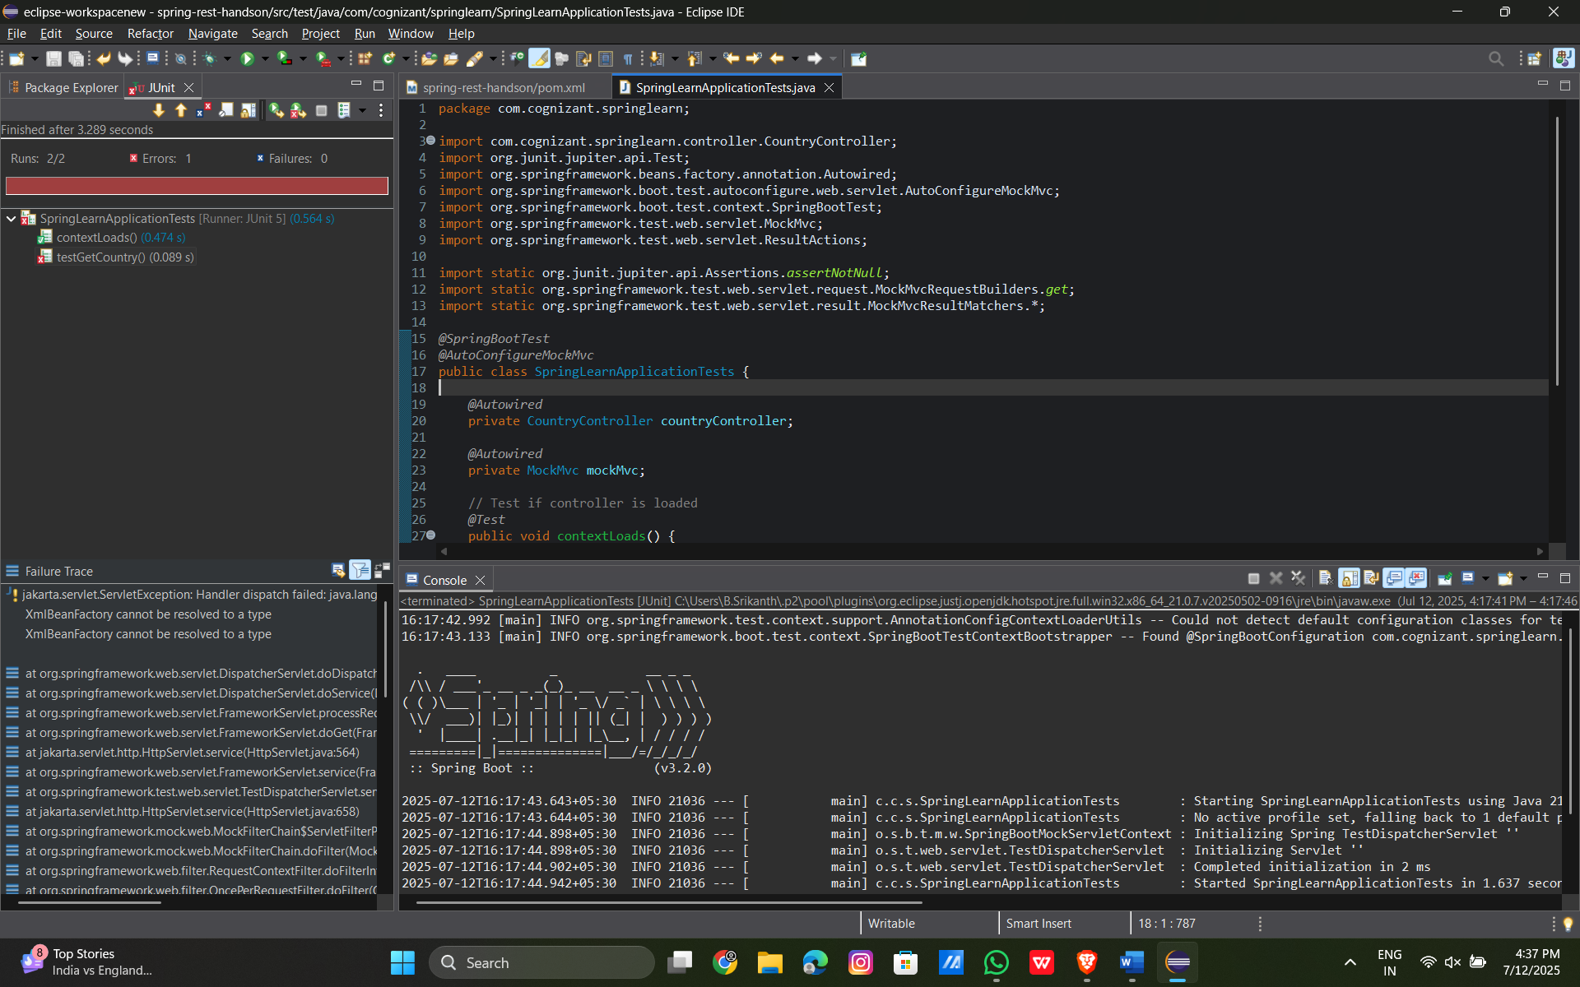
Hands On – 7:
MockMVC - Test get country service
Codes:
SpringLearnApplicationTests.java:
package com.cognizant.springlearn;
import com.cognizant.springlearn.controller.CountryController;
import org.junit.jupiter.api.Test;
import org.springframework.beans.factory.annotation.Autowired;
import org.springframework.boot.test.autoconfigure.web.servlet.AutoConfigureMockMvc;
import org.springframework.boot.test.context.SpringBootTest;
import org.springframework.test.web.servlet.MockMvc;
import org.springframework.test.web.servlet.ResultActions;
import static org.junit.jupiter.api.Assertions.assertNotNull;
import static org.springframework.test.web.servlet.request.MockMvcRequestBuilders.get;
import static org.springframework.test.web.servlet.result.MockMvcResultMatchers.*;
@SpringBootTest
@AutoConfigureMockMvc
public class SpringLearnApplicationTests {
@Autowired
private CountryController countryController;
@Autowired
private MockMvc mockMvc;
@Test
public void contextLoads() {
assertNotNull(countryController);
}
@Test
public void testGetCountry() throws Exception {
ResultActions result = mockMvc.perform(get("/country"));
result.andExpect(status().isOk());
result.andExpect(jsonPath("$.code").value("IN"));
result.andExpect(jsonPath("$.name").value("India"));
}
// Hands-On 7: Country not found test
@Test
public void testGetCountryException() throws Exception {
ResultActions result = mockMvc.perform(get("/countries/xyz"));
result.andExpect(status().isNotFound());
result.andExpect(status().reason("Country not found"));
}
}
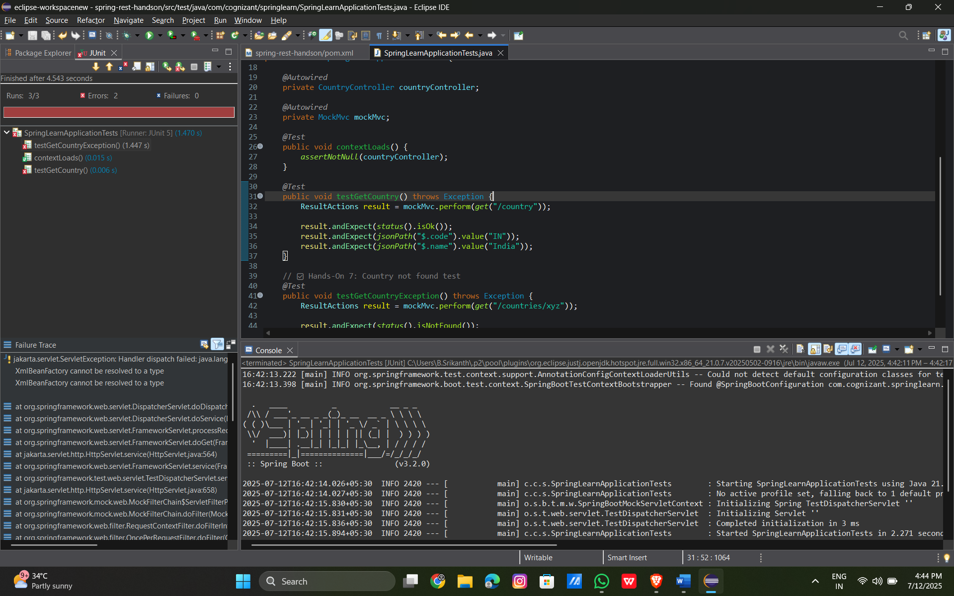

Hands On – 8
MockMVC - Test get country service for exceptional scenario
SpringLearnApplicationTests.java:
package com.cognizant.springlearn;
import com.cognizant.springlearn.controller.CountryController;
import org.junit.jupiter.api.Test;
import org.springframework.beans.factory.annotation.Autowired;
import org.springframework.boot.test.autoconfigure.web.servlet.AutoConfigureMockMvc;
import org.springframework.boot.test.context.SpringBootTest;
import org.springframework.test.web.servlet.MockMvc;
import org.springframework.test.web.servlet.ResultActions;
import static org.junit.jupiter.api.Assertions.assertNotNull;
import static org.springframework.test.web.servlet.request.MockMvcRequestBuilders.get;
import static org.springframework.test.web.servlet.result.MockMvcResultMatchers.*;
@SpringBootTest
@AutoConfigureMockMvc
public class SpringLearnApplicationTests {
@Autowired
private CountryController countryController;
@Autowired
private MockMvc mockMvc;
@Test
public void contextLoads() {
assertNotNull(countryController);
}
@Test
public void testGetCountry() throws Exception {
ResultActions result = mockMvc.perform(get("/country"));
result.andExpect(status().isOk());
result.andExpect(jsonPath("$.code").value("IN"));
result.andExpect(jsonPath("$.name").value("India"));
}
@Test
public void testGetCountryException() throws Exception {
ResultActions result = mockMvc.perform(get("/countries/xyz"));
result.andExpect(status().isNotFound());
result.andExpect(status().reason("Country not found"));
}
// Hands-On 8: /countries/IN test
@Test
public void testGetCountryByCodeSuccess() throws Exception {
ResultActions result = mockMvc.perform(get("/countries/IN"));
result.andExpect(status().isOk());
result.andExpect(jsonPath("$.code").value("IN"));
result.andExpect(jsonPath("$.name").value("India"));
}
}

